**BACHELOR DEGREE OF IT WITH ACCOUNTING**

**SOB-SUZA**

**BITA/5/21/012/TZ**

**REPORT OF MARK UP TEST**

**ADVANCED WEB TECHNOLOGY**

**First step**

I was use springboot initializer to to start spring boot project there I was choose the language of java which is programming language,write project properties and add dependencies which help in developing project like lombok,spring web and mysql driver

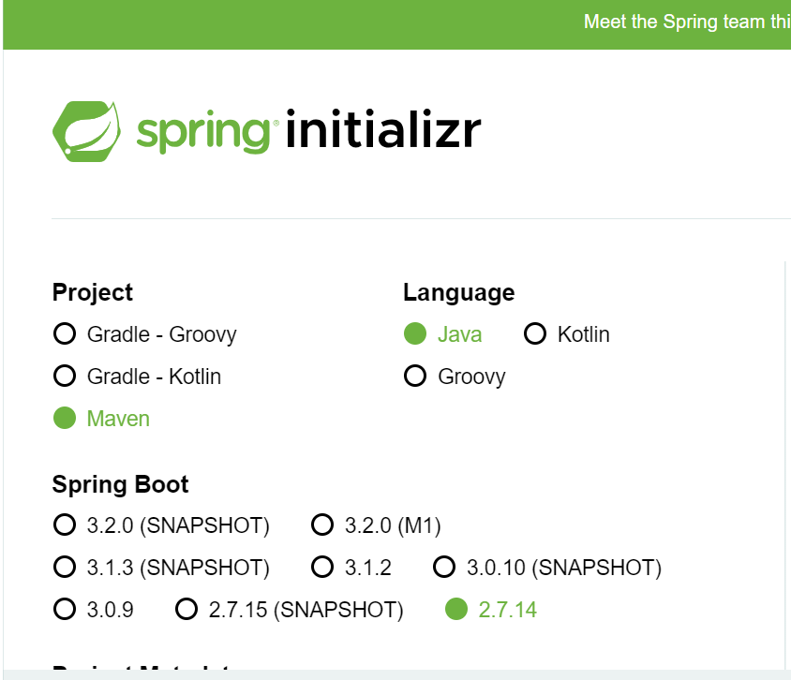

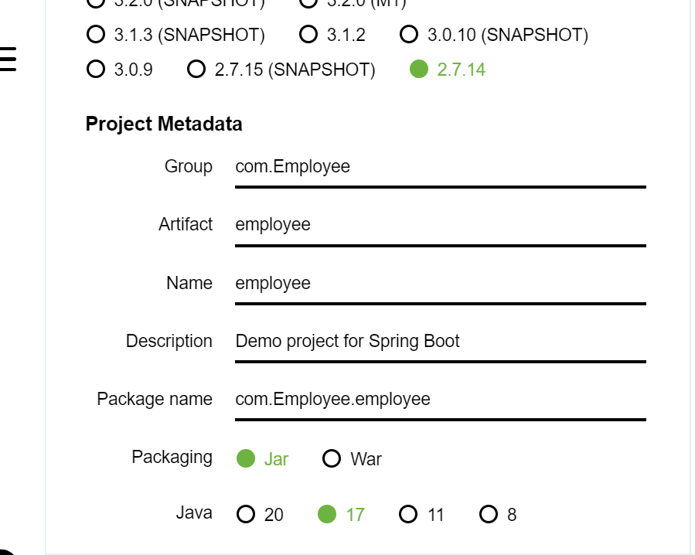

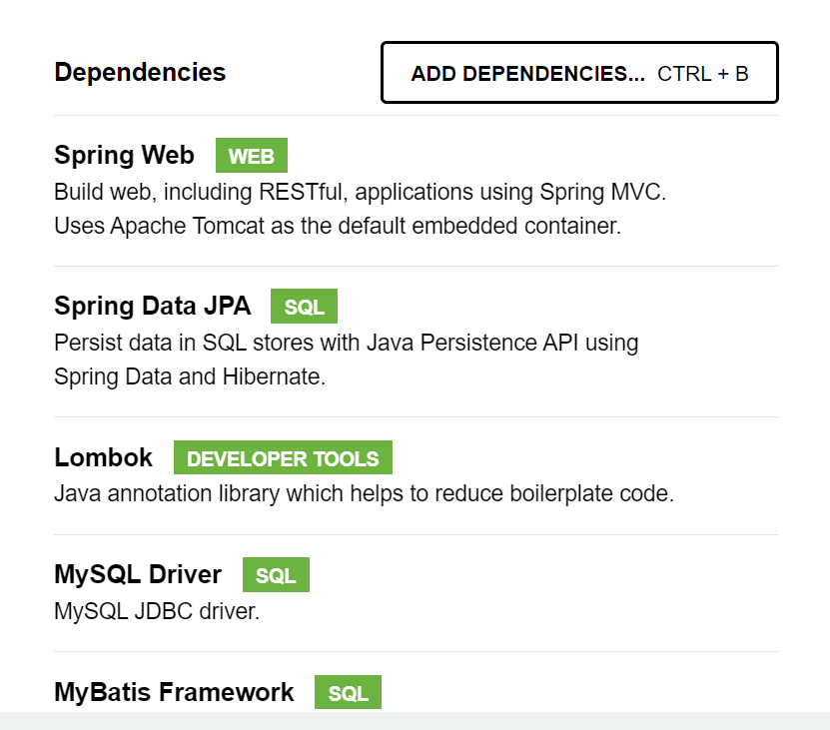

All dependencies are important since they play important role to ensure that the program is developed successfuly

**Second step**

Model, controller and repository folders are created so as to holds files that will carry codes of whole application

Then the model and repository files for employee detail are created within their folders as follows using visual studio codes

Codes for springboot project.java

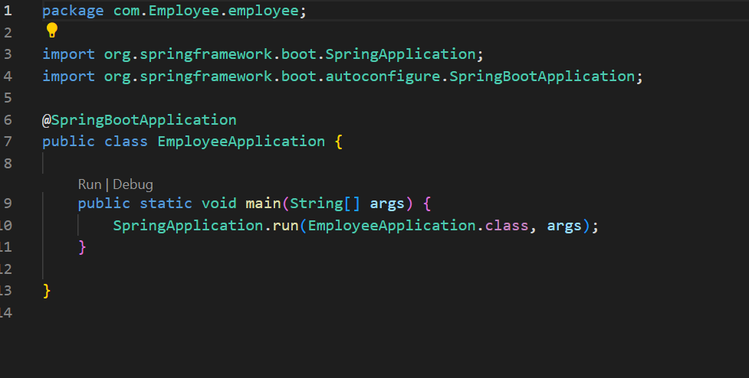

Codes for repository

Repository help to create interface class that will help when codes for controller and model will be created

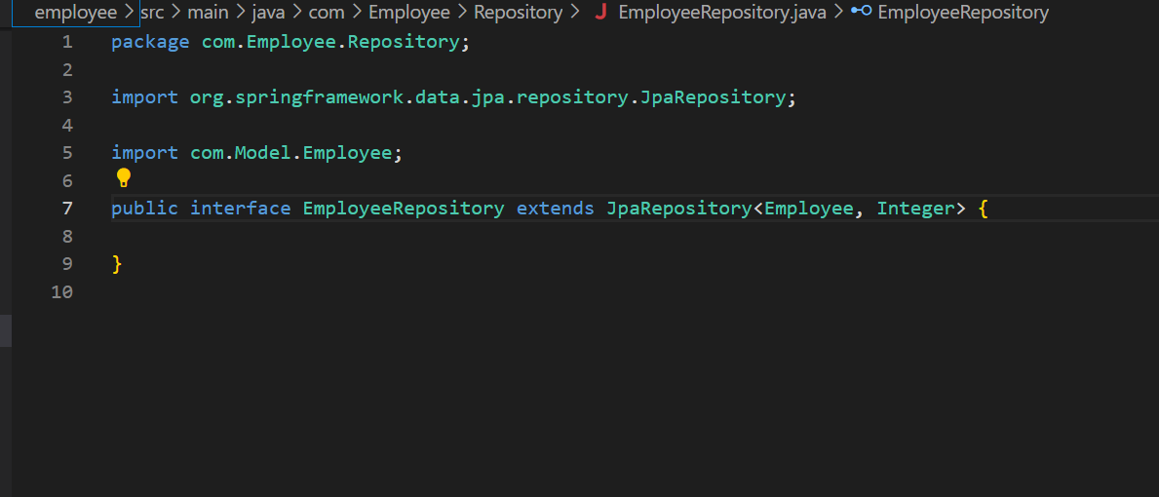

Codes for employee model

Models holds the file of employee that carry codes that initialize all details of employee like first name, last name and pasword

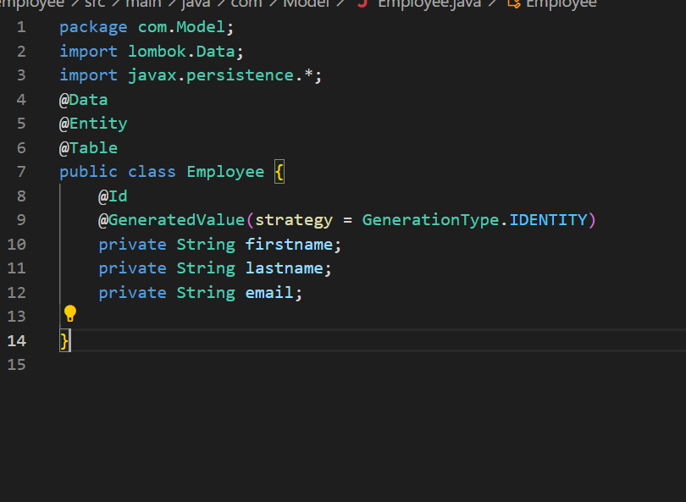

Codes for services and controller

Controller consist of codes that includes service of GET, PUT, DELETE and POST

package com.Controller;

import org.apache.ibatis.annotations.Delete;

import org.springframework.beans.factory.annotation.Autowired;

import org.springframework.http.ResponseEntity;

import org.springframework.web.bind.annotation.CrossOrigin;

import org.springframework.web.bind.annotation.DeleteMapping;

import org.springframework.web.bind.annotation.GetMapping;

import org.springframework.web.bind.annotation.PathVariable;

import org.springframework.web.bind.annotation.PostMapping;

import org.springframework.web.bind.annotation.PutMapping;

import org.springframework.web.bind.annotation.RequestBody;

import org.springframework.web.bind.annotation.RequestMapping;

import org.springframework.web.bind.annotation.RestController;

import java.util.List;

import java.util.HashMap;

import java.util.Map;

import java.util.Optional;

import com.Employee.Repository.EmployeeRepository;

import com.Model.Employee;

@CrossOrigin

@RestController

@RequestMapping("/api")

public class EmployeeController {

    @Autowired

    private EmployeeRepository employeeRepository;

    @GetMapping(" ")

    public List<Employee> getAllemployee(){

        return employeeRepository.findAll();

    }

    @PostMapping(" ")

    public Employee addEmployee(@RequestBody Employee employee){

        return employeeRepository.save(employee);

    }

    @DeleteMapping(" ")

    public ResponseEntity<Map<String,Boolean>> deleteEmployee(@PathVariable Integer id){

       Optional<Employee>  employee = employeeRepository.findById(id);

        Map<String,Boolean> response = new HashMap<>();

        response.put("your employee is deleted",Boolean.TRUE);

        return ResponseEntity.ok(response);

    }

    @PutMapping(" ")

    public ResponseEntity<Employee> updateEmployee(@PathVariable int id,@RequestBody Employee employee){

        Employee employee1 = employeeRepository.findById(id)

            .orElseThrow(() -> new ResourceNotFoundException("invalid id"));

        employee1.setFirstname(employee.getFirstname());

        employee1.setLastname(employee.getLastname());

        employee1.setEmail(employee.getEmail());

        return ResponseEntity.ok(employeeRepository.save(employee));

    }

}